**Maharshi Patanjali Vidya Mandir Prayagraj**

**HOLIDAYS HOME WORK**

Of

**Class XI-Biology Stream**

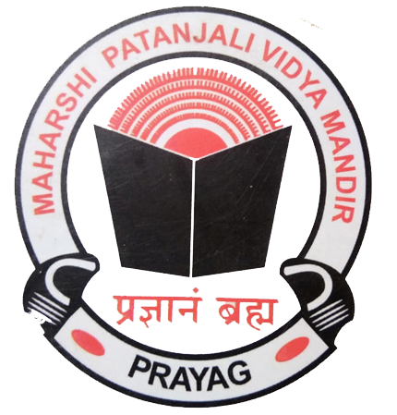

"Education's purpose is to replace an empty mind with an open one."

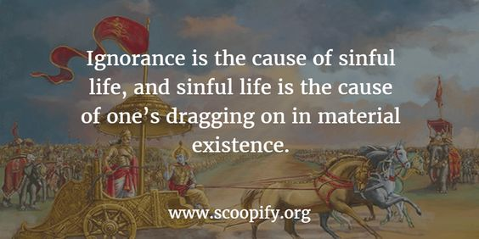



Real knowledge and education is not about storing masses of data in our brain; it means to have the wisdom to see every human being with equal vision.

|  |  |
| --- | --- |
| **English** | Learn the Question and answers of the following lessons:-  **HORNBILL**   1. The Portrait of a Lady  * A Photograph (poem)   **SNAPSHOTS**   1. The Summer of the Beautiful White Horse   **Practice the exercises on the given topic in**  **Grammar:-**  1.Tenses  **Make a video in pairs, on the topics given:-**  (Please follow these Instructions :-)  *Video should be of 1 minute 30 seconds duration and have to be sent in a compressed format.  * You will speak only on the topics given.  * Keep the video safely as you have to send it to the teachers in July.  **TOPICS FOR ONE AND A HALF MINUTE CONVERSATION**  1.Trying times  2. How to increase our immunity  3. Time Management  4. How I miss my school  5. My Ideal  6. Unpolluted nature- lockdown-lesson  OR  ROLEPLAY: TOPICS (Individual) Keep a hardcopy of the script   1. Policeman 2. Doctor 3. Journalist 4. Army Personnel 5. Teacher 6. Businessman |
| **Biology** | Prepare a short Video (maximum of 4 min 30 seconds) or PowerPoint Presentation on any one of the topics given below:  ❖ Major characteristics of living organisms.  ❖ Binomial nomenclature  ❖ Taxonomic Categories and Hierarchy  ❖ Taxonomical Aids  ❖ Classification system has undergone several changes over a period of time.  ❖ Major groups of Protista : (a) Photosynthetic Protists (b) Consumer- Decomposer Protists (c) Protozoan Protists  ❖ Types of Classification system (Artificial vs. Natural vs. Phylogenetic)  ❖ Types of Taxonomies (Numerical vs. Cytotaxonomy vs. Chemotaxonomy)  ❖ Life cycle of an Angiosperm  ❖ Plant Life Cycles  ❖ Features which act as basis of animal classification (like Levels of Organisation, Symmetry, germinal layers, Coelom, Segmentation etc.)  NOTE: (i) Topic should be selected only from the list given above.  (ii) Videos should be prepared only in school uniforms with Identity card.  (iii) Keep the videos safely as you have to send it to me in the month of July.  In case of any doubts students can contact me at 7052058495. |
| **Physics** | (Questions to be answered in short with diagrammatic representation if required)  Q. 1 Illustrate the practical applications of elasticity in the following examples:- I) bridges and II) cranes/lifts → their design feature and concept of elastic fatigue  Q. 2 Illustrate the biological connection of capillarity as used in paper chromatography.  Q. 3 Discuss any two practical uses or consequences of surface tension/angle of contact.  Q. 4 Geosynchronous satellite vs Polar satellite → Compare their differences and uses.  Q. 5 Discuss Bernoulli’s principle as used in case of  I) atomizer/sprayer  II )Magnus effect |
| **Chemistry** | (1)Do numericals from the mole concept studied in the class.  (2) Revise the chapter some basic concepts in chemistry.  (3) Write short notes on the discovery of electron, proton and neutron.  (4) Write short notes on the topics of environmental chemistry. |
| **Informatics Practices** | Write down the answers of the following questions.  1. What do you understand by cross platform language/software? Is Python a cross platform language?  2. What are the different working modes in Python? Explain.  3. What are the literals in python? How many types of literals are allowed in python?  4. What is single line string and multi-line string? Explain with example?  5. What is dynamic typing?  6. What will be the output produced by the following code : X=10 X=X+10 X=X-5 Print(X) X,Y = X-2, 22 Print(X, Y) X, Y = 20, 60 Y, X, Y = X, Y-10, X+10 Print(X, Y)  7. Write a python program that accepts marks of five subjects as input and produce average of marks as output.  8. A=10 B=20 Write a program to swap the value of A and B by using third variable and print the value of A and B. |
| **Physical Education** | 1. Revision of unit I 2. Make shorts notes of various topic – (athletic, basketball, football) 3. Practice of Asana ( tadasana, padmasana, Shashankasana) 4. Practice of meditation 5. Practice of home yoga fitness workout daily. |
| **Biotechnology** | **1. Revise the chapter**  The basic unit of life  **2. Answer the following questions:**  a) Draw the diagram of:   * Prokaryotic cell * Plant cell * Animal cell   b) Explain animal tissue.  c) Explain plant tissue.  d) Draw the diagram of nerve cell.  e) Define:   * Cell * Tissue * Organ * Organ system   **3. Practice the diagrams given in the chapter "The basic unit of life".** |
| **Hindi** | पढ़ाई गई कविताओं का शिल्प सौंदर्य लिखिए  2- गद्य खंड के प्रश्न उत्तर लिखिए एवं याद कीजिए  3- कोरोना संकट से बचाव का सुझाव देते हुए किसी प्रमुख समाचार पत्र के संपादक को पत्र लिखिए  4- सबको मिले शिक्षा का अधिकार विषय पर एक अनुच्छेद लिखिए |
| **Economics** | **Introductory Micro Economics –**   1. Central Problems of An Economy   Complete all the exercises and the questions given.  Practice doing numerical related to Production Possibility curve, MRT, MOC and Opportunity Cost.  Practice doing the diagrams related to rotation and shifting of PP curve  Read the chapter Consumer Equilibrium.  **Statistics For Economics –**  Read the chapter – Introduction Of Statistics  Learn and write various definitions of Economics, definition of Statistics, both singular and plural, sense, scope importance and distrust of Statistics.  Read the chapter Collection Of Data |
| **Legal Studies** | 1. Read unit I from the CBSE e book sent to you 2. Do all the objective type questions of chapter 1 and 2 from the CBSE book 3. Revise what was done in the class 4. Make the legal Studies project 5. Guide lines for the project 6. Make a project on any fundamental right   It should include the following headings  Article- Its words, meaning, commentary  Explanation of the Right  Decided cases explain the Right  10 Famous quotes on education - Education Today News |

“The aim of education should be to teach us rather how to think, than what to think — rather to improve our minds, so as to enable us to think for ourselves, than to load the memory with thoughts of other men.”

What we learn with pleasure we never forget.”

“Education is the passport to the future, for tomorrow belongs to those who prepare for it today.”

ENJOY YOUR HOLIDAYS